
Subject: Programming with Java
ASSIGNMENT No : 18
TITLE: Write a Java GUI program to demonstrate button click event handling.

Name: Avdhoot Mohite Class: CSE A2
PRN: 25070122056 Batch:25-29

Problem Statement
Write a Java GUI program to demonstrate button click event handling.
Learning Objectives
To implement button click events using Java event handling mechanisms.
Theory
Event handling allows Java programs to respond to user actions such as button clicks, mouse movements, and keyboard input. Swing uses ActionListener to process button click events. Event-driven programming separates user interface design from event-processing logic, making applications interactive and user-friendly.
Outcome
The programs were successfully implemented to demonstrate button click event handling using Java Swing. Buttons were created to perform addition and subtraction operations, and a Bank Balance Calculator was developed to perform deposit and withdrawal transactions. The updated results were displayed based on the button clicked by the user.
Conclusion
Thus, the experiment successfully demonstrated event handling in Java GUI applications using Swing. The ActionListener interface was used to handle button click events and perform the required operations. The experiment provided an understanding of event-driven programming and the development of interactive GUI applications.
Exercise
1. Create a GUI calculator where buttons perform addition and subtraction.
Java Program
import java.awt.*;
import java.awt.event.*;
import javax.swing.*;

public class assignment18a extends JFrame implements ActionListener {

JTextField num1Field, num2Field, resultField;
JButton addButton, subtractButton;

assignment18a() {
setTitle("GUI Calculator");
setSize(400, 300);
setLayout(new GridLayout(4, 2, 10, 10));
setDefaultCloseOperation(JFrame.EXIT_ON_CLOSE);

JLabel num1Label = new JLabel("First Number:");
JLabel num2Label = new JLabel("Second Number:");
JLabel resultLabel = new JLabel("Result:");

num1Field = new JTextField();
num2Field = new JTextField();
resultField = new JTextField();
resultField.setEditable(false);

addButton = new JButton("Add");
subtractButton = new JButton("Subtract");

add(num1Label);
add(num1Field);

add(num2Label);
add(num2Field);

add(resultLabel);
add(resultField);

add(addButton);
add(subtractButton);

addButton.addActionListener(this);
subtractButton.addActionListener(this);

setVisible(true);
}

public void actionPerformed(ActionEvent e) {
double num1 = Double.parseDouble(num1Field.getText());
double num2 = Double.parseDouble(num2Field.getText());

if (e.getSource() == addButton) {
resultField.setText(String.valueOf(num1 + num2));
} else if (e.getSource() == subtractButton) {
resultField.setText(String.valueOf(num1 - num2));
}
}

public static void main(String[] args) {
new assignment18a();
}
}

OUTPUT:
ADD
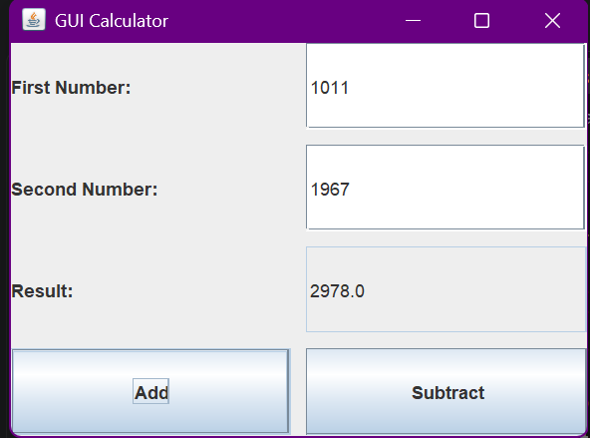

Subtract
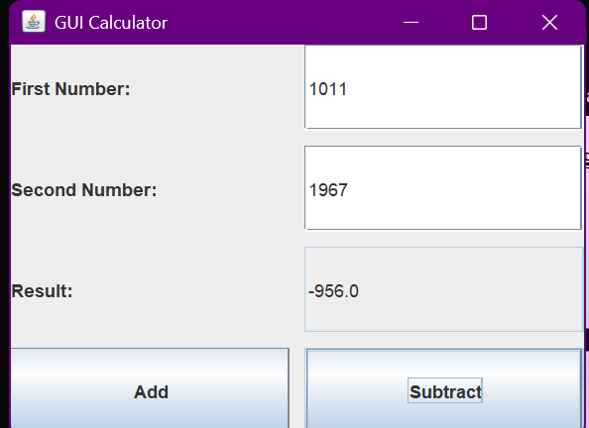
2. Create a Bank Balance Calculator GUI application using Java Swing where the user enters the initial balance and transaction amount. Use buttons to perform addition (deposit) and subtraction (withdrawal) and display the updated balance.
Java Program
import java.awt.*;
import java.awt.event.*;
import javax.swing.*;

public class assigment18b extends JFrame implements ActionListener {

JTextField balanceField, amountField, resultField;
JButton depositButton, withdrawButton;

assigment18b() {
setTitle("Bank Balance Calculator");
setSize(450, 300);
setLayout(new GridLayout(4, 2, 10, 10));
setDefaultCloseOperation(JFrame.EXIT_ON_CLOSE);

JLabel balanceLabel = new JLabel("Initial Balance:");
JLabel amountLabel = new JLabel("Transaction Amount:");
JLabel resultLabel = new JLabel("Updated Balance:");

balanceField = new JTextField();
amountField = new JTextField();
resultField = new JTextField();
resultField.setEditable(false);

depositButton = new JButton("Deposit");
withdrawButton = new JButton("Withdraw");

add(balanceLabel);
add(balanceField);

add(amountLabel);
add(amountField);

add(resultLabel);
add(resultField);

add(depositButton);
add(withdrawButton);

depositButton.addActionListener(this);
withdrawButton.addActionListener(this);

setVisible(true);
}

public void actionPerformed(ActionEvent e) {
double balance = Double.parseDouble(balanceField.getText());
double amount = Double.parseDouble(amountField.getText());

if (e.getSource() == depositButton) {
double updatedBalance = balance + amount;
resultField.setText(String.valueOf(updatedBalance));
}
else if (e.getSource() == withdrawButton) {
double updatedBalance = balance - amount;
resultField.setText(String.valueOf(updatedBalance));
}
}

public static void main(String[] args) {
new assigment18b();
}
}

OUTPUT:
Deposit:
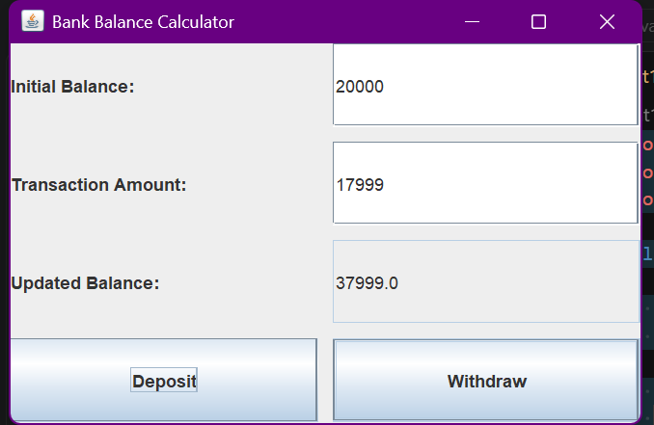

Withdraw:
